**Earl of Lathom Lodge No.2560**

The April and May Meetings of the Lodge were suspended following a letter from the MW Grand Master dated the 17th March 2020.

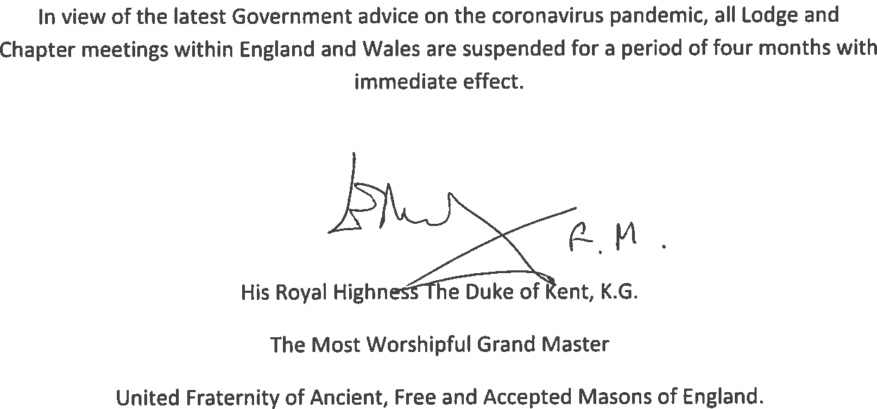

Signed

………………………………………………..

WBro Malcolm N Ashton, *JP,* PProvGSwdB, Secretary